Dear NDRA Supporter

Club fees are due with a NZDRA National Series event on our calendar this coming season, the fees have been set at - Racer Membership $160.00, Social Membership $60.00 and any Racer Membership, this is for a new club member, the fee will be $80.00 for the first season.

This fee will cover you for racer entry for ALL NDRA events but not the NZDRA licence fee. If you have Pit Crew, it is advised that they become Social Members.

For those that would normally purchase a Day Licence, it would be of advantage to you to purchase a Sportsman Licence through the NZDRA website and can be done now. This will cost $95.00 and will cover you for the whole season at any NZDRA/IHRA event anywhere in NZ.
http://www.nzdra.co.nz/membership-licence-application-form.

This form once completed can be dropped to Gourdie Automotive with payment or posted to
NDRA, PO Box 7030, NELSON 7040
Bank deposit can be made to: Nelson Drag Racing Association, Westpac Bank, 03-0703-0347617-00
PLEASE make sure to add your name as the reference so we can identify who has made the payment.

Regards
Ashlee Ilton
Secretary
NDRA

PLEASE PRINT CLEARLY
- -------------------------------------------------------------------------------------------------
Nelson Drag Racing Association Inc 2019 Season
PO Box 7030
Nelson 7042 Please Circle one
Social | Racer
$60.00 | $160.00

Membership Application

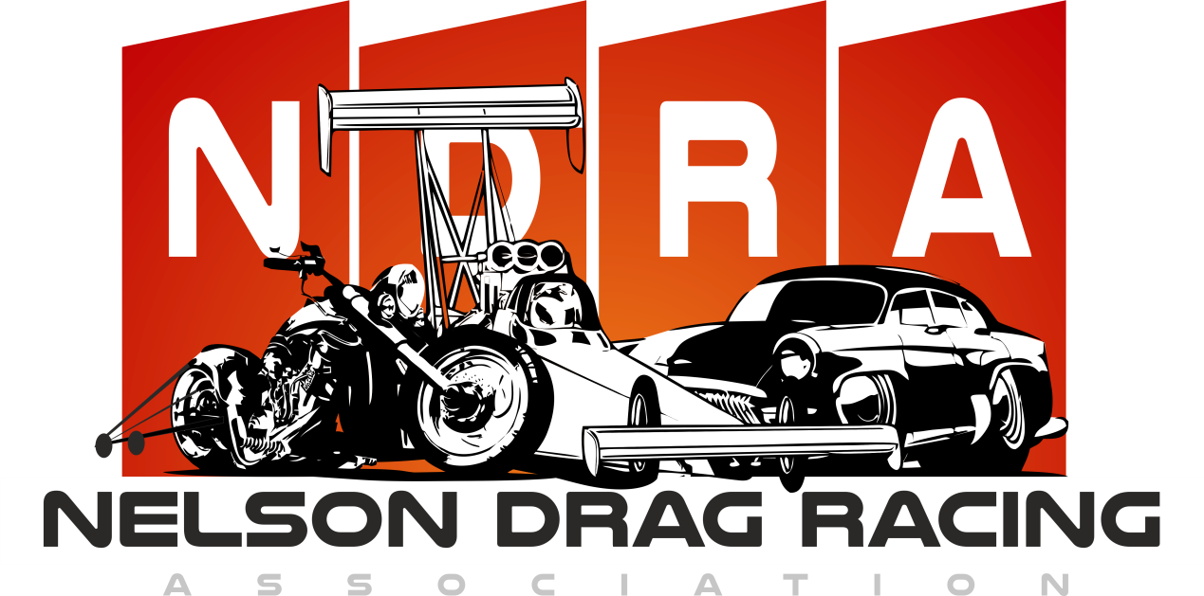
Name: __________________________________________

Partner: __________________________________________
Children 12 to 17 yrs: _________________________________
Address: __________________________________________
__________________________________________
Postal Code: ______________
Phone No: ( ) _____________________________________
Cell Phone:_________________________________________
Email: __________________________________________

Signed: _____________________
Date: _____________________

